Georgia State Parks and Historic Sites
Weekend Summary
07.13.2020

Crowds:
- Extreme heat has been a factor this week, affecting day use visitation especially in South Georgia. Sites that had to temporarily limit day use access due to capacity include: Cloudland Canyon, Tallulah Gorge, Vogel, Tugaloo, Sweetwater Creek, and Red Top Mountain.

- Golf Course activity continues to be high, 61% over last year this past week. This weekend they saw reduced play due to the heat, especially in the afternoon. Richard B. Russell and Red Top reported the most boating activity over the weekend.

Staffing issues:
- As of Monday, the Division has 17 part-time and full-time staff out due to COVID-19 related reasons.
- Mistletoe currently has three employees out, Fort King George has two employees out, Fort McAllister has two, Gordonia has one, Laura Walker has one, and Reynolds Mansion has one due to COVID-19 situations and testing. Hard Labor Creek has had staff shortages due to COVID-19, so coverage has been provided from within the region and headquarters.

Positives
- Overall, this past weekend parks did not have to temporarily limit access as often as in past weekends. Several sites reported better compliance with social distancing this weekend.
- Providence Canyon will be returning the GDOT signage and barrels since crowds are no longer an issue.
- Skidaway Island had a new first-time camper who got their camper stuck when backing it into the site. Staff assisted with the situation and the campers had a great experience.
- Website Statistics continue to be high. This past weekend total pageviews were up 65% with 1.3 million views this week. Reservation pageviews were up 74% and the Alerts Page received 14,199 pageviews.

Challenges
- At Crooked River, a shelf collapsed that was holding formaldehyde and other chemicals, creating a hazmat cleanup situation, and forcing the removal of all live animals. Staff and animals are all O.K.
- Laura Walker found evidence from an unsuccessful attempted theft in a collection box (fishing line with a flattened sinker and hook).
- Some sites had challenges with cleaning and scheduling due to the high turnover and staff shortages. Vogel had 20+ cottage turnovers on Sunday and Don Carter and F.D. Roosevelt have limited staff.
- Panola is working with LED on surveillance for the Vaughter’s Barn due to recent break-ins.
- At Elijah Clark, there was a minor domestic/noise dispute in the campground that the local SO responded without incident.
- Mistletoe staff responded to an ATV in the day-use area and a couple of dogs off leashes.

Financial Update
Past Weekend:
Overall occupancy for all reservables increased 12% this past weekend to 71%. Camping increased 16%, reaching 87% occupancy. Yurts were at 95% occupancy, 13% higher than the previous year. Cottage rentals slightly declined by 1% to 87% occupancy.
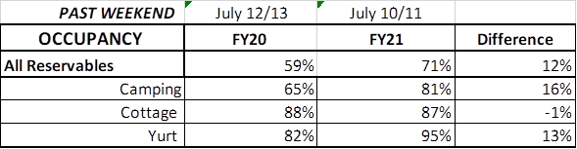
Upcoming Weekend:
For the upcoming weekend, there is a 4% increase in all reservables at 68% occupancy. Camping is showing a 7% increase and yurts are showing a 16% increase with 97% reserved. Cottages are showing a 4% decrease down to 86% occupancy.
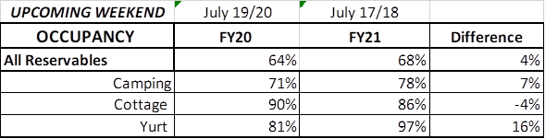
Revenue:
This past week, July 6th - 12th, there was a 2% or $15,600 decrease in overall revenue. This decrease can mainly be attributed to the reservation booking policy change.
For overnight accommodations – camping revenue continues to significantly increase. This past week camping revenue improved 20% or $45,000. Cottage revenue decreased 10% or $23,000. Yurts improved 9% or $900. Note: The reservation policy changed on July 1st from collecting all revenue at the time of booking to only a 50% deposit. That is the reason for no longer seeing a significant increase to overnight accommodation revenue.
This past week, ParkPass revenue increased 32% or $34,000 compared to last year.
Golf was up 61% this past week or $20,000.
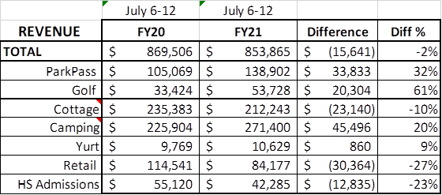
Historic site admissions declined in comparison to last year by 23% or $13,000.

Cancellations/Refunds:
During COVID19, there have been 38,000 reservation cancellations, including $3.4 Million in actual refunds and a loss of future revenue of $15 Million. This is 2,000 more than last Monday, when we were at 36,000 cancellations. This is the highest increase in cancellations in the past 2 months. Last year during the same week there were 600 cancellations, thus there were 1,400 more cancellations this past week than last year during the same time period.
Last year during March through YTD, there were 15,000 cancellations, including $786,000 in actual refunds and a loss of future revenue of $3.8 Million. So, total cancellations have increased over 23,000 or 153% and the amount of refunds have increased $2.6 Million.

